Quick find
- In this tutorial it’s explained on how to connect components according to the id’s.
- Here the integer array of Size N is taken as given below.
- Here p and q are connected if and only if they have the same id. (interpretation)
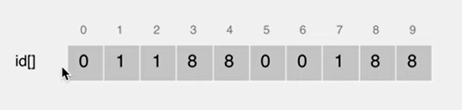
- According to this diagram here;
  - 0,5 and 6 are connected as they have the same index<0>
  - 1,2 and 7 are connected as they have the same index<1>
  - 3,4,8 and 9 are connected as they have the same index<8>
- Here in order to have connected components the id’s having to be same. If it’s not then to merge the components containing p and q, we must replace all values of id p to id q.

